Project Identification

Project: | Time Management/Scheduling Application
Prepared By: | Umit Kilinc  Ravkeerat Singh  Josiah Galloway
Document Version: | 1.0
Published Date: | January 5, 2023

Contributors
The following individuals contributed to this document.
Name | Title
Umit Kilinc | Owner/Developer
Ravkeerat Singh | Owner/Developer
Josiah Galloway | Owner/Developer

Distribution
This document is distributed to all the following people.
Name | Title
Anjana Shah | Program Coordinator

Referenced Documents
This document refers to the following materials
Version number | Title | Author | Date | Source / Location

Revision History

Version Number | Revision Date | Summary of Changes | Modified by
[Note: It is recommended that drafts be numbered 0.1 to 0.9, and that the first approved version be numbered 1.0. Thereafter, new version numbers will depend upon changes: 1.01, 1.1, etc for minor updates, 2.0, 3.0 etc for major changes.]

TABLE OF CONTENTS
1. Business Context Diagram 3
2. REquirements Scope Statements 4
3. High Level Business Requirements (HLR) Traceability 4
4. High Level Business Requirements Sign-Off 5

- Business Context Diagram
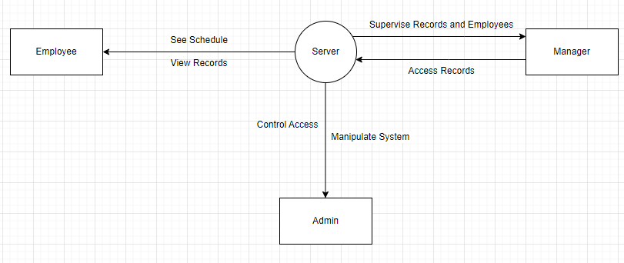

Requirement Scope Area | Description
Server | An application server where the ones with access the necessary records whenever needed.

External Entity | Description
Manager | A user who can access the records and make changes in scheduling.
Employee | A user with access to viewing schedules and records.
Admin | A user with access to manipulate the system
Server | Where all the data is stored.

Information Flows | Description
See Schedule | Viewing posted and previous schedules.
View Records | Viewing current and previous hours worked and money made pre-tax.
Control Access | To create, edit, and delete new admin or employee profiles.
Manipulate System | To make changes, updates, and modifications to the system.
Access Records | To view employee schedules, requested time-offs, and total money paid to the employees.
Supervise Records and Employees | Publish new schedules, edit existing schedules, and approve or deny requested time-offs.
- Requirements Scope Statements
HLR# | Description | Priority  (H, M, L)
 | Employee should be able to see their schedules and hours worked. | H
 | Employee should be able to request time-offs. | H
 | Employee should be able to see a breakdown of the money made during the scheduled time. | M
HLR04 | Employee should be able to punch-in and punch-out. | H
HLR05 | Manager should be able to create and update employee schedules. | H
HLR06 | Manager should be able to approve or deny requested time-offs. | H
HLR07 | Manager should be able to access each employees’ previous schedules and money made. | M
HLR08 | Admin should be able to create, edit, or delete manager profiles. | H
HLR09 | Admin should be able to edit the system and tend to its needs. | H

- High Level Business Requirements Sign-Off
The undersigned acknowledge their agreement with the contents of Version <x.x> of the High-Level Requirements document for <Project Name>.

Following approval of this document, requirements changes will be governed by the project’s change management process, including impact analysis and appropriate reviews and approvals, under the general control of the Project Plan and according to company policy. Approved Change Request Documents, if present, will be attached to this Requirements Document as updates.

Name | Project Role and  Functional Area | Date Signed

* Note: physical signatures are not required. Email approvals are acceptable and should be appended to project documents.

